“Duty, Valour, Sacrifice, WW2” Teacher’s Guide
About the simulation:
The “Duty, Valour, Sacrifice” simulation was not designed as a game. No score is kept. The only rewards are occasional promotions and continued survival. The purpose of the simulation is to allow students to learn about and to appreciate what our soldiers, sailors, airmen experienced in the war. My hope was that the simulation format would make learning about the war more engaging without devolving into entertainment.
DVS allows students to select which service they wish to join – the Canadian Army, the RCN and the RCAF. The simulation section for each service is designed to be covered in two to three 75 minute classes, even allowing time for the students to puzzle out challenges and read the information notes and letters home. As a suggestion, students might be paired up, to allow more students access if computers are limited. One third of the class might be assigned to each service – army, navy, air force – to allow students to compare experiences. Students are also free to access the simulations outside of class time.
Historical Accuracy
I have tried to make the simulation as authentic as possible. The research was extremely extensive, extending through five years. The chronology, description of major events and battles and all letters, memoirs and diary entries are all authentic. The tests and challenges are all based on information and situations from the time period – often borrowed from people’s memoirs or biographies. Over 95% of the images are also authentic, sometimes with a little graphic editing for clarity.

Using “Duty, Valour, Sacrifice” in the Classroom
The simulation program consists of series of linked web pages. This means that students can access any screen in the simulation at any time simply by entering the URL address. At the end of a class students can "bookmark" the screen they stopped at and resume the simulation from that point later. Students can also backtrack - go back a screen or two - to learn information for the tests and challenges – without affecting the flow of the program. As well, students are also able to access Google or other information sites without closing the simulation.
Here are suggested ways to use “DVS WW2” in a classroom setting:
1. Create a whole class activity using a Smartboard or Brightlink. Have the teacher or a student navigate through the simulation, asking the class for input. It could be used in this way as an introductory activity or as a review exercise – either year by year or for the entire war years. Teachers could also use a smart board in a whole class setting to present one of the tests or challenges and have the entire class discuss possible answers. After the class has discussed the possible choices and expected consequences and selected a best choice, the teacher could move on to the answer screen to see the result. The teacher could also go back and look at the results for the other choices as well.
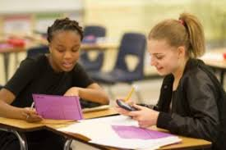
2. Use the simulation as a “hook” to lead into actual World War II events. As students reach key moments in the simulation they could read up or do research on that event, have the teacher explain the event to the entire class, or have one class group do a presentation on that particular event. Use the simulation as an introduction to learning more about events mentioned in the simulation such as: Dieppe, the Italian Campaign, D-Day. Students can also investigate details of a typical soldier’s experiences in such areas as equipment, uniforms, diet, and complaints.
3. The teacher could simply put the students into pairs, have each pair select a Service and then go through the scenario in two or three classes. As students progress through the simulation they could work on a related assignment – a historical “scavenger hunt”, creating a time line, recording information on key battles, creating a “Top Ten” list related to the war, etc.

4. Students can compare notes with other class members on topics such as who survived, who died, and how each handled different experiences. What “lessons learned” can the class generate from their collective experiences?
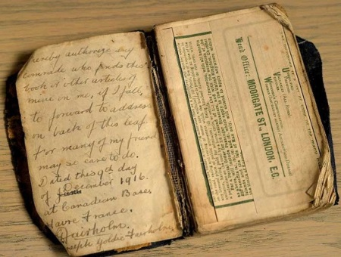
Assignment Ideas
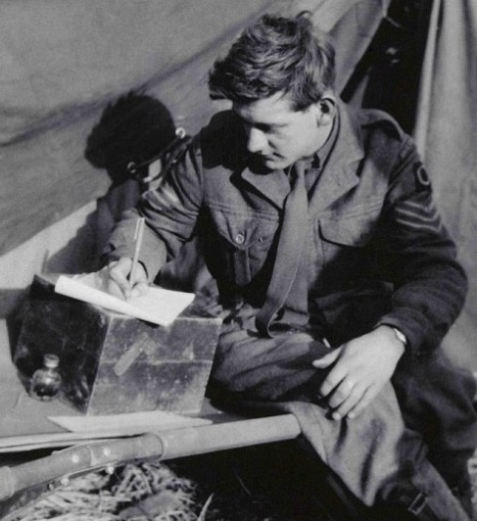
5. Have students keep a diary during the simulation. Students can maintain a year-by-year record of where the soldier is, what he is doing, and his perceptions of the war. Based on this, students can create a World War II events time line for Canadian and International events. In addition, the students can write a reflective journal of their perceptions, thoughts, and reflections about war.
6. Have students compare the hypothetical soldier’s experiences to those of actual soldiers. Students can use the links to the letters, diary entries and memoirs to research more about the soldiers who wrote them. This could be tied into the “Lest We Forget” Library and Archives Canada program. They could also search for letters or diaries written by local veterans. The “Letters Home” in the simulations are all authentic. To see the originals, visit Vancouver Island University’s “Canadian Letters and Images Project” at http://www.canadianletters.ca/collections/469/S. The Dominion Institute’s “Memory Project” provides another way students can read about the experiences of actual war veterans and compare them to what they experienced in the simulation. Visit the Memory Project's web site at www.thememoryproject.com.

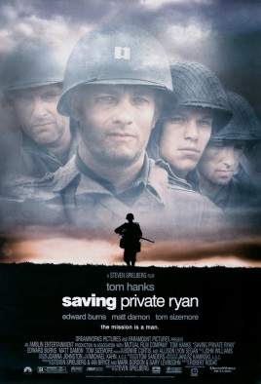
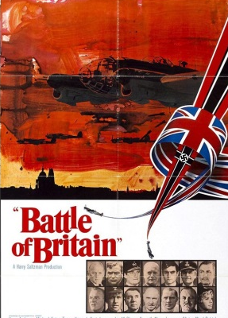
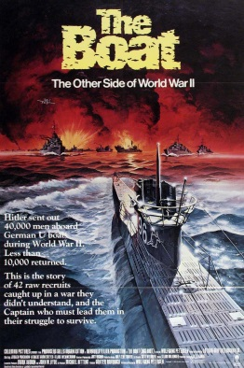

7. Have students compare what they’ve experienced in the simulation with what they’ve seen in movies about the wars. Possible movies include “Dunkirk”, “Battle of Britain”, “Dieppe”, “The Big Red One”, “Saving Private Ryan”, “A Bridge Too Far”, “Memphis Belle”, “Das Boot”, “Enemy at the Gates”.

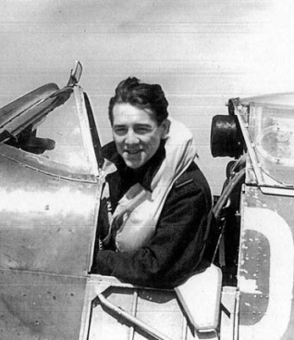
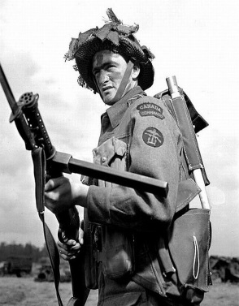
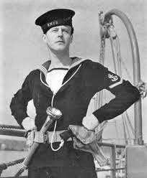

8. Have students compare the experiences of a Canadian soldier, sailor and airman. Which service would you rather have been in, and why?
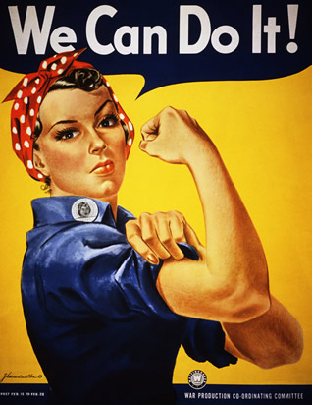
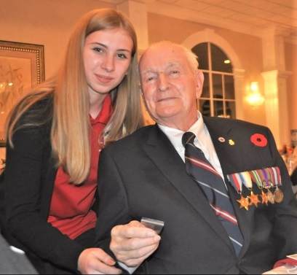
9. Ask students what new appreciation has the simulation given you for our veterans? If they could ask three questions of a veteran from the army, navy, or air force, what would they be?

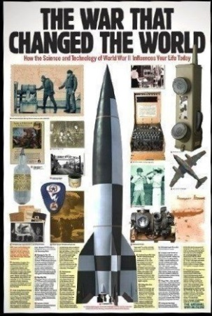
10. Have students research more on the “Home Front” and on women’s contributions during the war: the women who joined an auxiliary military service, became nurses, those who went to work in industry, and those at home.

11. Have students investigate the impact of changes in technology in the war. How did technological changes affect the land, air and sea wars?

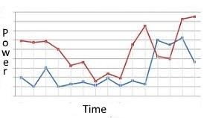
12. Have students create a power-time graph to chart the course of the war in Europe, who is winning, who is losing from 1939 to 1945. Explain the when, how and why of the rise and fall of each side.

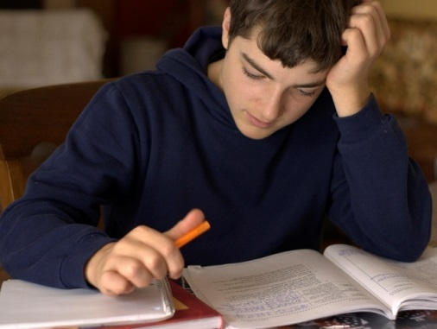
13. Use the simulation as a review tool. Students can take events they have learned about in class and see how they tie together, from the perspective of a Canadian soldier. Students can compare what they learned in class with the way the simulation presents each event.

14. Have students write a reflective journal during and after their experiences on such topics as:
a. How it felt to be a typical front-line soldier going into battle: - A front line soldier’s experiences and emotions before and during an attack
- How battles were fought in WW2 as compared to WW1. How a soldier’s combat experiences would be different in the two wars
- How dependent front line soldiers were on the attack planners. Individual soldiers have no control over their destiny
b. What was learned about the nature of war: - What has to be done to the enemy in order to win a battle
- How even great victories come at a price in human lives
- The randomness and unfairness of war, simple chance can determine who lives or dies.
- How wartime can involve months of tedium followed by one day of terror, years of training come down to one real battle
c. Canadian Pride and the wars: - How good were the Canadian leaders and soldiers compared to the British, American, Russian, and German armies?
- Why we should feel proud of what Canadians achieved in WWI and WWII

Historical Thinking – The “Big Six” Historical Concepts
Based on http://historicalthinking.ca/historical-thinking-concepts
To think historically, students need to be able to six distinct but closely interrelated historical thinking concepts:
- Establish historical significance
- Use primary source evidence
- Identify continuity and change
- Analyze cause and consequence
- Take historical perspectives
- Understand the ethical dimension of historical interpretations.
Taken together, these concepts tie “historical thinking” to competencies in “historical literacy.” In this case, “historical literacy” means gaining a deep understanding of historical events and processes through active engagement with historical texts.
Historically literate citizens can assess the legitimacy of claims people have made related to History. (“History proves that . . .”, “History tells us that . . . “) They can interrogate historical sources. They know that a historical film can look "realistic" without being accurate. They understand the value of citing sources. In short, they can detect the differences, between the uses and abuses of history. “Historical thinking” only becomes possible in relation to substantive content. These concepts are not abstract “skills.” Rather, they provide the structure that shapes the practice of history.
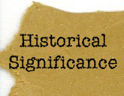

- Establish Historical Significance:
What is historically significant? How significant is something in History?
Sample activities: After going through the simulation students are asked to identify the most historically significant events and developments. The teacher provides them with specific events or developments and asks them to assess how significant each was. Students are asked to assess how significant Canadians contributions to the war were? Students examine individual soldier’s experiences and try to link their stories to larger trends such as training camp issues, daily life/dangers at the front, the course of battles, new battle technology and tactics, changes in morale, issues in racism and sexism.

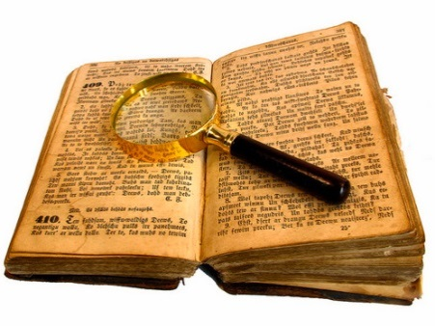
- Use Primary Source Evidence:
Reading a source for evidence demands a different approach than reading a source for information. A history textbook is generally used more like a phone book: it is a place to look up information. Primary sources must be read differently. To use them well, we set them in their historical contexts and make inferences from them to help us understand more about what was going on when they were created. Once we establish what the evidence is, and whether or not it is legitimate, we examine it to see if it offers clues about the person who owned or created it, when the evidence was made, what it tells us about its creator, and what else was going on at that time.
Sample activities: What can we infer from the primary evidence from the war? Students are asked to examine original diaries artifacts and images presented in the simulation and draw inferences concerning the people who created them. Students could draw inferences concerning a soldier’s thoughts/fears/attitudes towards serving in the war: training camp life and preparation for combat, surviving trench life, combat dangers, and attitudes towards their leaders and the war as a whole.

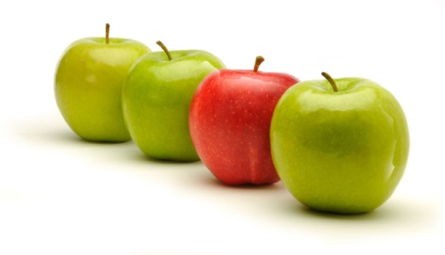
- Identifying Continuity and Change:
Students sometimes misunderstand history as a list of events. Once they start to understand history as a complex mix of continuity and change, they reach a fundamentally different sense of the past. There were lots of things going on at any one time in the past. Some changed rapidly while others remained relatively continuous. Judgments of continuity and change can be made on the basis of comparisons between some point in the past and the present, or between two points in the past.
Sample activities: Where can we find examples of continuity and change in the war? What stays the same, what changes – and in what ways? Students are asked to find examples of change and continuity through the war years, in training techniques, daily routines for our soldiers, sailors and airmen, their attitudes, weapons and equipment, types of fighting, and the progress of the war - who is winning, who is losing?

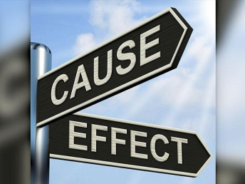
- Analyze Cause and Consequence
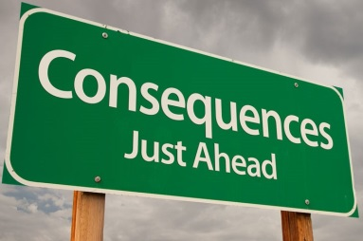
In examining both tragedies and accomplishments in the past, we are usually interested in the questions of how and why. These questions start the search for causes: what were the actions, beliefs, and circumstances that led to these consequences? In history, as opposed to geology or astronomy, we need to consider human agency. People, as individuals and as groups, play a part in promoting, shaping, and resisting change. People have motivations and reasons for taking action (or for sitting it out), but causes go beyond these. We also have to look at the larger context. Causes are thus multiple and layered, involving both long-term ideologies, institutions, and conditions, and short-term motivations, actions and events. Causes that are offered for any particular event (and the priority of various causes) may differ, based on the scale of the history and the approaches of the historian.
Sample activities: WWII is full of examples of examples of cause and consequence. Students can find examples of cause and effects in the origins of the war, why the German Blitzkrieg was so successful at first - and its consequences, the evolution of the U-Boat war, the origins and consequences of Germany's attack on the USSR and Japan's attack on Pearl Harbor, the evolution of the Allies' mass bombing campaign, origins and consequences of the Western Allies Italian and Normandy invasions, the origins and consequences of Germany's "Final Solution" and the Holocaust, and the many consequences of the Allied victory in the war.
- Take Historical Perspectives
Understanding the foreignness of the past is a huge challenge for students. But rising to the challenge illuminates the range of human behaviour, belief and social organization. It offers surprising alternatives to the taken-for-granted, conventional wisdom, and opens a wider perspective from which to evaluate our present preoccupations. Taking historical perspective means understanding the social, cultural, intellectual, and emotional settings that shaped people’s lives and actions in the past. Understanding diverse perspectives is a key to historical perspective-taking. Though it is sometimes called “historical empathy,” historical perspective is very different from the common-sense notion of identification with another person. Indeed, taking historical perspective demands comprehension of the vast differences between us in the present and those in the past.

Sample activities: Students will use evidence from the simulation to investigate how Canadians in 1939 viewed and understood their world. They will discover how people felt when war was declared and what they thought the war will be like. They will investigate how attitudes to the war changed over time with changes in military technology, and the increasing destructiveness and brutality of the fighting. Students will use documents from the simulation to learn what soldiers thought of their purpose and role in the military and how this changed during the war. They will also investigate peoples’ attitudes to other groups – minorities, women, the government, military leadership, the British, the enemy, etc. as well as what they thought the result would be and the world that would be created afterwards.
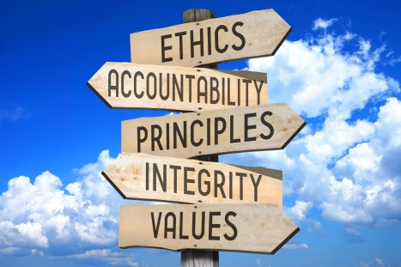
- Understanding Ethical Dimensions of History
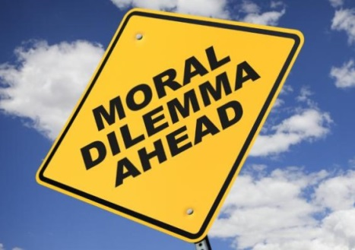
Taking historical perspective demands that we understand the differences between our ethical universe and those of bygone societies. We do not want to impose our own anachronistic standards on the past. At the same time, meaningful history does not treat brutal slave-holders, enthusiastic Nazis, and marauding conquistadors in a “neutral” manner. Historians attempt to hold back on explicit ethical judgments about actors in the midst of their accounts, but, when all is said and done, if the story is meaningful, then there is an ethical judgment involved. We should expect to learn something from the past that helps us to face the ethical issues of today.
Sample activities: Students will investigate key ethical issues in the war: inadequate training leading to soldiers sent to their deaths by poor planning and errors on leadership, deliberate attacks on defenseless civilian populations, changes in military technology leading to increasing destructiveness and brutality in the fighting: mass aerial bombing, use of atomic bomb, should more have been done much earlier to stop the Holocaust? Students will explore ethical issues related to sexism and racism, the treatment of Women, Indigenous Peoples, French-Canadians, Canadian Blacks, and the internment of Japanese-Canadians.

The Ontario Curriculum, Grades 9 and 10, Canada and World Studies, Revised 2013
http://www.edu.gov.on.ca/eng/curriculum/secondary/canworld910curr2013.pdf
Here are the key Strands and Threads from the Ontario Canada and the World Curriculum related the “Duty, Valour, Sacrifice”:
C1. Social, Economic, and Political Context: Describe some key social, economic, and political events, trends, and developments between 1929 and 1945, and assess their impact on different groups in Canada. In what ways were conflicts during this period different from those earlier in the century? What might account for those differences? In what ways did events during this period reflect Canadians’ views on human rights? Did the Canadian government respect the human rights of all people during this period? What impact did events during this period have on Canada’s response to later human rights issues?
C1.2. Identify some major developments in science and/or technology during this period (e.g. military technologies such as sonar, radar, walkie-talkies, or the atomic bomb), and assess their significance for different groups in Canada
C1.4 Describe the main causes of some key political developments and/or government policies in Canada during this period (e.g., the decision to intern Japanese Canadians; the 1944 Racial Discrimination Act), and assess their impact on different groups in Canada
C2.Communities, Conflict, and Cooperation: Analyse some key interactions within and between communities in Canada, and between Canada and the international community, from 1929 to 1945, with a focus on key issues that affected these interactions and changes that resulted from them This was a period of strained and shifting relationships between groups in Canada as well as between Canada and other countries.
C2.2 Analyse how some key issues and/or developments affected Canada’s relationships with Great Britain and the United States during this period (e.g., the Lend-Lease Agreement; military involvement in World War II)
C2.3 Explain the main causes of World War II (e.g., economic hardship in Germany produced by the Treaty of Versailles and economic depression; invasions by fascist Italy, Nazi Germany, and imperial Japan; the inadequacy of the League of Nations to address international crises), and analyse Canada’s contribution to the war effort (e.g., with reference to the Battle of the Atlantic, the Battle of Hong Kong, the Italian campaign, D-Day, the liberation of the Netherlands, the liberation of concentration camps, the British Commonwealth Air Training Plan, Camp X, the contributions of women)

C2.4 Explain some of the ways in which World War II affected Canada and Canadians (e.g., with reference to economic recovery, censorship, rationing), including how the war changed the lives of various groups in this country (e.g., young men who fought and those who did not; farmers; women in the workforce and at home; “enemy aliens”; veterans, including men who were in the merchant navy)
C3. Identity, Citizenship, and Heritage: Explain how various individuals, groups, and events, including some major international events, contributed to the development of identity, citizenship, and heritage in Canada between 1929 and 1945. The actions of various individuals and groups had a major impact on the continuing development of Canada during this time. (e.g. Mackenzie King, Max Aitken, Buzz Beurling, Tommy Prince, William Stephenson, Matthew Halton )
C3.1 Describe contributions of various individuals, groups, and/or organizations to Canadian society, politics, and/or culture during this period and assess the significance of these contributions for the development of identity, citizenship, and/or heritage in Canada.
C3.2 Analyse responses of Canada and Canadians to some major international events and/or developments that occurred during this period (e.g., aggression by Fascist Italy, Nazi Germany, and Imperial Japan; the Holocaust; the Manhattan Project), and assess the significance of these responses, including their significance for Canadian identity and heritage.
C3.3 Analyse the impact of the Holocaust on Canadian society and on Canadians’ attitudes towards human rights (e.g., with reference to changes in Canadians’ responses to minority groups; more open refugee policies, including those affecting Holocaust survivors and other displaced persons; Canada’s signing of the United Nations Universal Declaration of Human Rights; the evolution of laws against hate crimes)

